Topic: Measurement | EQ: How can we informally measure?
Questions  What is informal measure?  Measure body parts | Discussion: (DO NOT ADD TO NOTES)  Before the metric system came in as a standard way to measure different things there was the imperial system (some countries still use the imperial system). The imperial system was based off of body parts mostly.  Inch= the width of a thumb  Foot= length of a foot  Fathom= arm span  Notes:  To help people estimate measurements or informally measure we can use our body parts. This is a handy tool when you don’t have measuring instruments like rulers and measuring tape.  Complete the following table using your body parts (you will need a tape measure or ruler)  Body part Approximate use Length (cm)  - Top section of thumb Small lengths  - Little finger Small lengths  - Hand span Small lengths  - Foot (shoe) Short distances on the ground  - Pace Walking distances  - Fathom (arm span) Lengths of fabric or rope  Guide of where to measure.  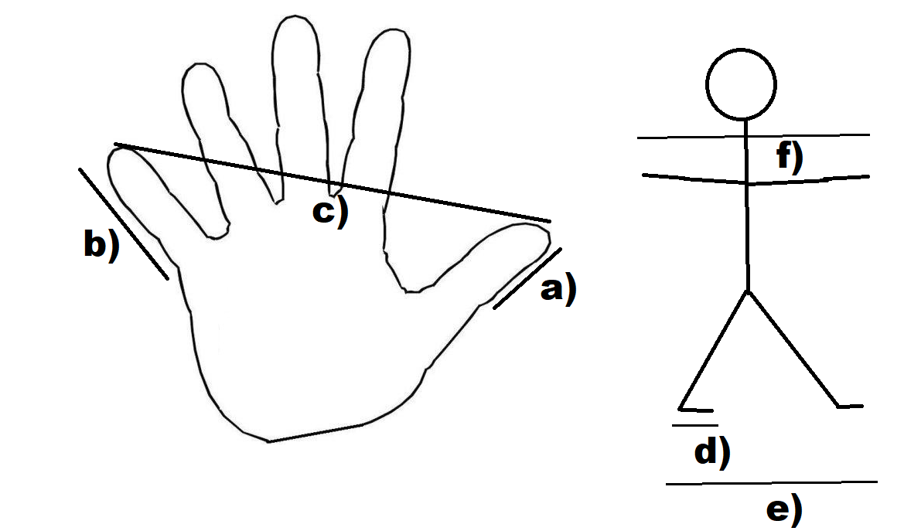

Activity

Use your body measurements and calculation to approximate each length

Use an appropriate unit. Use paces, feet and fathoms for longer distances and thumb, little finger and hand span for small distances.
Object | Body measurement | Approximate measurement (cm)  Hint: multiply your body measurement buy the actual length of body part
The length of your bedroom
The length of a piece of A4 paper
Length of your calculator
Length of a pen
Height of your desk (or table)
Width of a window
Distance from your bedroom to the kitchen
Height of your front door

Use google or actually measure the items to see how close your approximations are

